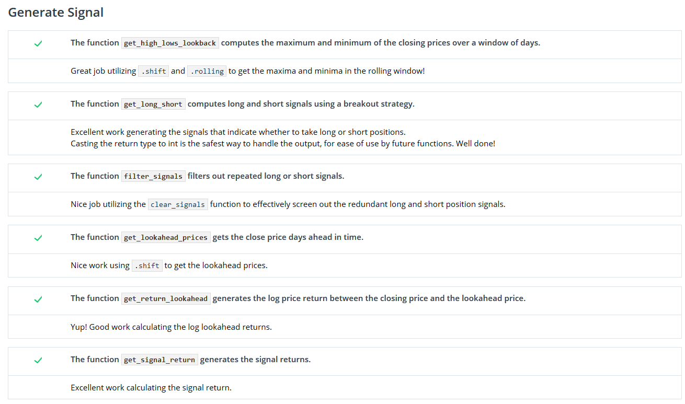

Generate Signal

The function get_high_lows_lookback computes the maximum and minimum of the closing prices over a window of days.

Great job utilizing .shift and .rolling to get the maxima and minima in the rolling window!

The function get_long_short computes long and short signals using a breakout strategy.

Excellent work generating the signals that indicate whether to take long or short positions.  
Casting the return type to int is the safest way to handle the output, for ease of use by future functions. Well done!

The function filter_signals filters out repeated long or short signals.

Nice job utilizing the clear_signals function to effectively screen out the redundant long and short position signals.

The function get_lookahead_prices gets the close price days ahead in time.

Nice work using .shift to get the lookahead prices.

The function get_return_lookahead generates the log price return between the closing price and the lookahead price.

Yup! Good work calculating the log lookahead returns.

The function get_signal_return generates the signal returns.

Excellent work calculating the signal return.

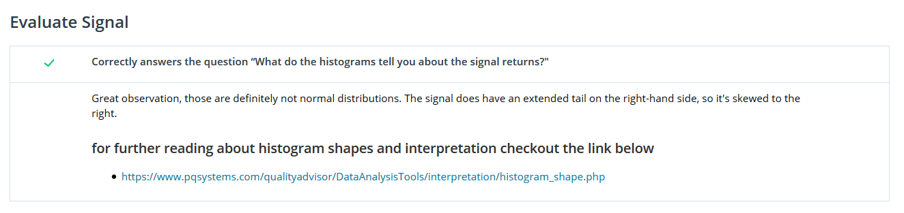Evaluate Signal

Correctly answers the question “What do the histograms tell you about the signal returns?"

Great observation, those are definitely not normal distributions. The signal does have an extended tail on the right-hand side, so it's skewed to the right.

For further reading about histogram shapes and interpretation checkout the link below

* <https://www.pqsystems.com/qualityadvisor/DataAnalysisTools/interpretation/histogram_shape.php>

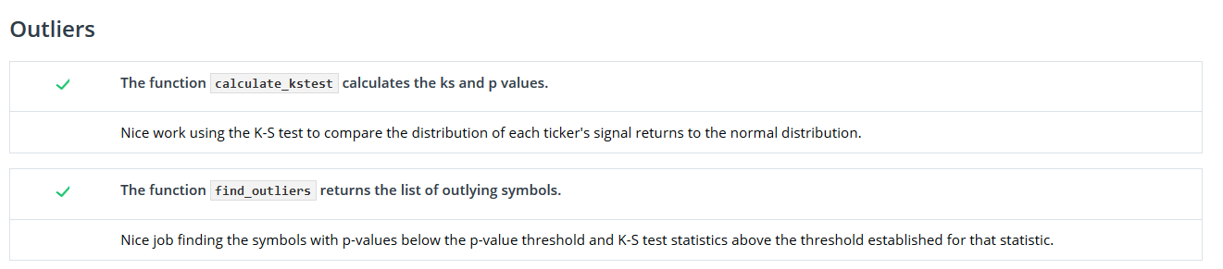

Outliers

The function calculate_kstest calculates the ks and p values.

Nice work using the K-S test to compare the distribution of each ticker's signal returns to the normal distribution.

The function find_outliers returns the list of outlying symbols.

Nice job finding the symbols with p-values below the p-value threshold and K-S test statistics above the threshold established for that statistic.